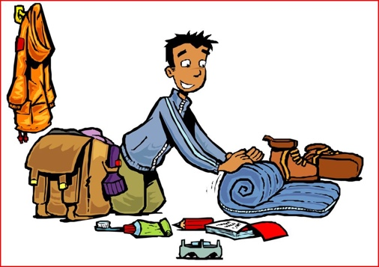
Packing List

What to bring:

- Bible
- Casual clothes
- Recreational clothes
-All shirts must have sleeves
-All shorts must pass the “fingertip rule”
- Swimsuit (optional)
-must be a one-piece or you may wear a t-shirt over a two-piece
- Twin bed sheets OR sleeping bag
- Pillow
- Shampoo & body wash/soap
- Deodorant
- Toothbrush & toothpaste
- Towel
- Snacks for your room (remember that Fusion Camp provides snack after each evening worship)
- Optional:
-Playing cards, tennis racket, Frisbee, etc (for free time)
-spending money for vending machines
A word about cell phones:
Please limit use of cell phones to pictures, your Bible app, or during free time
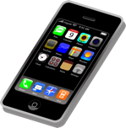

What NOT to bring:

- Ipods, Ipads, portable speakers, gaming devices, etc
- Scooters, skateboards, hover boards, etc
- Fireworks or prank items
- Alcohol, drugs, cigarettes, vaping devices, etc
- Anything inconsistent with a Christian testimony

